PROJECT DESIGN PHASE
Auto Ticket Classification using Flow Designer
- Introduction
The project titled “Auto Ticket Classification using Flow Designer” is designed to automate the classification of support tickets in ServiceNow. When a new ticket is created, the Flow Designer workflow reads the ticket information, identifies the appropriate category using predefined conditions or keywords, updates the ticket, and routes it to the relevant assignment group. This reduces repetitive manual work and helps maintain a consistent ticket-handling process.

2. Project Objective
- To automatically classify newly created support tickets.
- To use ServiceNow Flow Designer for workflow automation.
- To reduce manual classification and routing of tickets.
- To update ticket fields based on predefined classification rules.
- To route tickets to the appropriate assignment group.
- To improve consistency and speed in the ticket-handling process.

3. Existing System
In a manual ticket-handling process, a support agent checks the ticket description and decides its category and assignment group. The agent then updates the ticket and routes it manually. This can take additional time and may lead to inconsistent classification when many tickets are received.

4. Proposed System
The proposed system uses ServiceNow Flow Designer to automate ticket classification. A flow is triggered when a new ticket is created. The flow obtains the ticket details, checks them against predefined conditions, determines the category, updates the ticket record, and routes the ticket to the appropriate assignment group.

5. System Design
The system is designed as an event-driven workflow. The main input is a newly created ticket. The processing layer contains the Flow Designer trigger and classification logic. The output is an updated and correctly routed ticket.
Component | Purpose | Example
Ticket Record | Stores the support request | Incident / Case record
Flow Designer | Controls the automation workflow | Trigger, conditions and actions
Classification Logic | Identifies the ticket category | Keyword or condition-based rules
Update Action | Changes ticket fields | Category / assignment group
Assignment Group | Receives the classified ticket | Hardware / Software / Network team

6. System Flowchart
The following flowchart shows the overall working sequence of the proposed system.
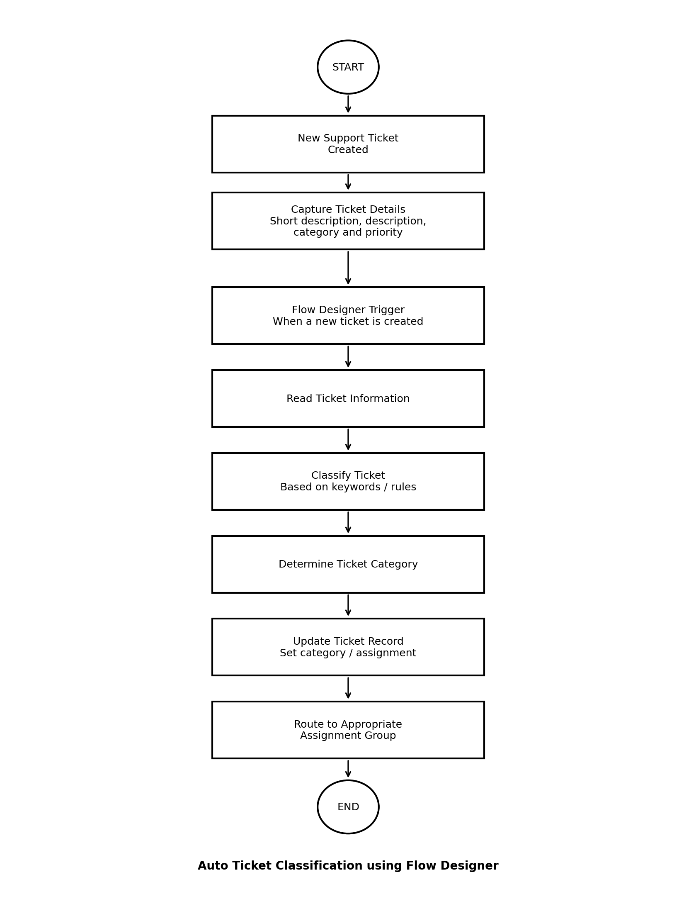

7. Flowchart Explanation
Step 1 – Start: The automation process begins when the workflow is ready to process a ticket.
Step 2 – New Support Ticket Created: A new support ticket is submitted in ServiceNow.
Step 3 – Capture Ticket Details: The system reads important fields such as short description, description, category and priority.
Step 4 – Flow Designer Trigger: The flow starts automatically when the defined ticket creation condition is satisfied.
Step 5 – Read Ticket Information: The flow obtains the required ticket values for classification.
Step 6 – Classify Ticket: The flow checks the ticket information against predefined conditions or keywords.
Step 7 – Determine Ticket Category: A suitable category is selected according to the classification rules.
Step 8 – Update Ticket Record: The selected category and related fields are written back to the ticket.
Step 9 – Route to Assignment Group: The ticket is directed to the appropriate support group.
Step 10 – End: The automated classification and routing process is completed.

8. Flow Designer Components
Trigger – Starts the flow when a new ticket is created or when the specified record condition is met.
Actions – Perform tasks such as reading values, updating records, and assigning the ticket.
Conditions – Check ticket information and select the correct classification path.
Data Pills – Pass values from the ticket record into later flow steps.
Update Record – Stores the classification result in the ticket.

9. Classification Logic Design
The classification logic can be implemented using conditions in Flow Designer. For example, words related to hardware, software, network or access can be used to select an appropriate category. The actual keywords and categories can be modified according to the organization's ticket structure.
Ticket Information | Example Condition | Classification
Hardware-related description | Contains hardware-related keywords | Hardware
Software-related description | Contains software/application keywords | Software
Network-related description | Contains network/connectivity keywords | Network
Access-related description | Contains login/access keywords | Access
No matching condition | No predefined rule matches | Default / Review

10. Module Design
- Ticket Creation Module: Receives and stores a new support ticket.
- Trigger Module: Starts the Flow Designer flow based on the configured trigger.
- Classification Module: Checks ticket information using predefined conditions.
- Ticket Update Module: Updates category and other required ticket fields.
- Assignment Module: Routes the ticket to the selected assignment group.

11. Input and Output Design

Input | Output
New ticket record | Classified ticket
Short description | Updated category
Detailed description | Selected assignment group
Existing ticket fields | Updated routing information

12. System Architecture
architecture follows a simple input–process–output model. The ServiceNow ticket acts as the input. Flow Designer performs the processing and classification. The ServiceNow database stores the updated ticket, while the assignment group receives the routed ticket.
User | ServiceNow Ticket | Flow Designer | Classification | Assignment Group
Creates ticket
 | Stores ticket
 |  | Runs workflow
 |  |  | Determines category
 |  |  |  | Receives ticket

13. Functional Requirements
- The system shall allow a user or process to create a support ticket.
- The system shall trigger the Flow Designer workflow according to the configured condition.
- The system shall read the required ticket information.
- The system shall compare ticket information with predefined classification rules.
- The system shall update the ticket with the identified category.
- The system shall assign or route the ticket to the appropriate assignment group.
- The system shall preserve the ticket information after processing.

14. Non-Functional Requirements
- The workflow should be simple and maintainable.
- The classification rules should be easy to modify.
- The system should process tickets consistently.
- The workflow should avoid unnecessary manual steps.
- The design should use standard ServiceNow Flow Designer capabilities where possible.

15. Error and Exception Handling
- If required ticket information is missing, the flow should avoid applying an incorrect classification.
- If no classification rule matches, the ticket can be assigned a default category or sent for manual review.
- If an update action fails, the ticket should remain available for manual processing.
- Classification rules should be tested with different ticket descriptions before deployment.

16. Test Case Design
Test Case | Input | Expected Result | Status
TC01 | New ticket with hardware-related text | Hardware category is selected | To be tested
TC02 | New ticket with software-related text | Software category is selected | To be tested
TC03 | New ticket with network-related text | Network category is selected | To be tested
TC04 | New ticket with access-related text | Access category is selected | To be tested
TC05 | Ticket without matching keywords | Default/manual review path is used | To be tested

17. Tools and Technologies
- ServiceNow Platform
- Flow Designer
- Incident / Ticket Management
- ServiceNow Tables and Records
- Web Browser

18. Expected Result
After implementation, a newly created support ticket should automatically pass through the configured Flow Designer workflow. The ticket information should be checked against the classification rules, the appropriate category should be selected, the ticket should be updated, and it should be routed to the relevant assignment group. Tickets that do not match a rule should follow a predefined default or manual-review path.

19. Conclusion
The project design provides a structured approach for automating ticket classification using ServiceNow Flow Designer. The design separates ticket creation, triggering, classification, record update, and assignment into clear workflow stages. This provides a suitable foundation for implementing and testing the Auto Ticket Classification system.

